**Topics: Descriptive Statistics and Probability**

1. Look at the data given below. Plot the data, find the outliers and find out $μ, σ, σ^{2}$

|  |  |
| --- | --- |
| **Name of company** | **Measure X** |
| Allied Signal | 24.23% |
| Bankers Trust | 25.53% |
| General Mills | 25.41% |
| ITT Industries | 24.14% |
| J.P.Morgan & Co. | 29.62% |
| Lehman Brothers | 28.25% |
| Marriott | 25.81% |
| MCI | 24.39% |
| Merrill Lynch | 40.26% |
| Microsoft | 32.95% |
| Morgan Stanley | 91.36% |
| Sun Microsystems | 25.99% |
| Travelers | 39.42% |
| US Airways | 26.71% |
| Warner-Lambert | 35.00% |

ANS:

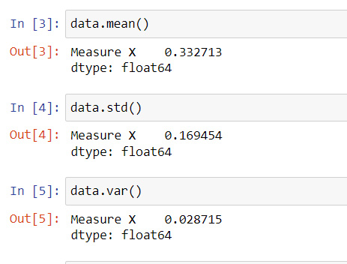

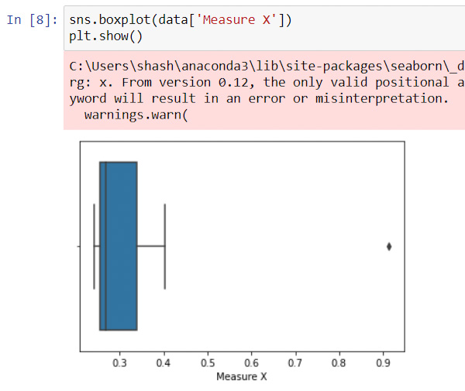

* Mean = 0.332
* Standard deviation = 0.169
* Variance = 0.0287
* The outlier is 91.36%



Answer the following three questions based on the box-plot above.

1. What is inter-quartile range of this dataset? (please approximate the numbers) In one line, explain what this value implies.

ANS:

IQR = Q3-Q1

=12-5

=7

1. What can we say about the skewness of this dataset?

ANS:

From the above box plot, most of the data towards the left side, hence data is right side.

1. If it was found that the data point with the value 25 is actually 2.5, how would the new box-plot be affected?

ANS:

* If the value is 2.5, then there will be no outliers in the data.
* The median will shift to next positive value, since it is plotted using median



Answer the following three questions based on the histogram above.

1. Where would the mode of this dataset lie?

ANS:

It lies between 4 to 8.

1. Comment on the skewness of the dataset.

ANS:

Most of the data lies towards left side, it is right skewed

1. Suppose that the above histogram and the box-plot in question 2 are plotted for the same dataset. Explain how these graphs complement each other in providing information about any dataset.

ANS:

* Boxplot helps to find the outliers, median, interquartile range and maximum and minimum values.
* Histogram helps to find the frequency of occurrence in the data.
* Compared to boxplot, the data distribution is clearly shown in Histogram
* Skewness can be determined easily in boxplot than histogram

1. AT&T was running commercials in 1990 aimed at luring back customers who had switched to one of the other long-distance phone service providers. One such commercial shows a businessman trying to reach Phoenix and mistakenly getting Fiji, where a half-naked native on a beach responds incomprehensibly in Polynesian. When asked about this advertisement, AT&T admitted that the portrayed incident did not actually take place but added that this was an enactment of something that “could happen.” Suppose that one in 200 long-distance telephone calls is misdirected. What is the probability that at least one in five attempted telephone calls reaches the wrong number? (Assume independence of attempts.)

ANS:

Probability of getting wrong number (p) = 1/200

Probability of not getting wrong number (q) = 199/200

By using binomial distribution equation,

When x=0, p(x) = 0.975

When x>=1, p(x) = 1-0.975

= 0.245

1. Returns on a certain business venture, to the nearest $1,000, are known to follow the following probability distribution

|  |  |
| --- | --- |
| x | P(x) |
| -2,000 | 0.1 |
| -1,000 | 0.1 |
| 0 | 0.2 |
| 1000 | 0.2 |
| 2000 | 0.3 |
| 3000 | 0.1 |

1. What is the most likely monetary outcome of the business venture?

ANS:

Outcome = (-2000*0.1) +(-1000*0.1) +(0*0.2) +(1000*0.2) +(2000*0.3) +(3000*0.1)

=800

1. Is the venture likely to be successful? Explain

ANS:

The most likely outcome is 800, hence the venture is successful

1. What is the long-term average earning of business ventures of this kind? Explain

ANS:

Outcome = (-2000*0.1) +(-1000*0.1) +(0*0.2) +(1000*0.2) +(2000*0.3) +(3000*0.1)

=800

1. What is the good measure of the risk involved in a venture of this kind? Compute this measure

ANS:

V(x) = 2160000

Sd(x) = 1469.69